Computer Language Coding Concept

Connections
This section covers any kind of connection between objects, that are a result of accessing system aspects. First the graphical overview of all possible system aspect connections are displayed. After that the details are covered.

Object Get | Object Set
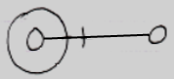 | 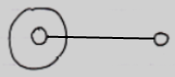
Use As Class | Class Set
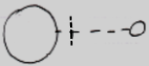 | 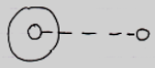
Value Get |  | Value Set
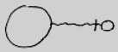 |  | 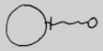
Clone (2) Get |  | Clone (2) Set
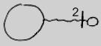 |  | 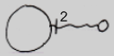
New |  | Annul
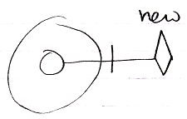 |  | 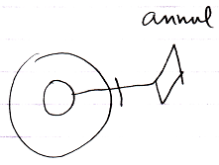
Something |  |  | Nothing
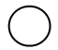 |  |  | 
Execute
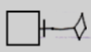
Add | Remove
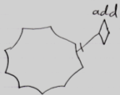 | 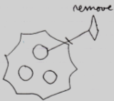

Outward and Inward Connections
The Object Set connection is an outward connection.

Outward connections do not have access marks. Inward conections do have access marks:

This is not only because outward connections are more common, but also because an outward connection is more passive than an inward connection.

When a symbol is inward connected:

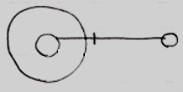

each consult of the symbol on the right, that connects inwards, results in a call to to the Get of the target symbol. So the connection is more active in that each consult of the source object requires a Get on the target object. Inward connections are also called Get connections.

When a symbol is outward connected:

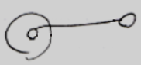

the symbol is directly connected to the target object. It stores the ID of the target object and refers to it directly, without executing a Get on each consult. The outward directed connection may have been established through acccess to a Set command, but that call is history. The connection does not have to pass through to the insides of another object. Outward connections are called Set connections. However, the Set action is history and all that matters is the result, not how it was established.

Passing through to the inside of another object requires a the Get command of the target symbol to be executed.

This also conforms to the idea of automatic containment. In automatic containment, outward directed connections are automatically established: automatically drawn out in the diagram without an intervention of a programmmer. Inward directed connects were actively established by the programmer. They follow a qualification before getting to the final object. They are more active and display an access symbol and result in active Get’s taking place all the time.

Remarks

Class Connections
Use As Class and Class Set are covered here. Class Get is not covered here, because that is only used in an assignment, and assignments are addressed in other articles.

Value Connections
Note that the indication of direction for Get and Set is switched for the Value aspect, compared to the Object aspect: Object Get is inward, while Value Get is outward.

What you can also notice is that outward Value connections do have access marks, while outward connections for the Object and Class aspects do not show access marks. This is because outward Object and Class connections are passive connections and outward Value connections are active connections, because an Value connection always requires an active assignment.

Value connections are assignments, but they do not have an ‘assignment notation’.

Data Connections
A Data connector such as the following:

Data Get
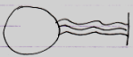

is an abstract connector: it represents any possible Get connection to any sub-sub-object. Even though there is a Data connector, there are no Data connections. Any Get connection to a sub-object is be considered a Data Get connection.

Clone Connections
The diagrams above show access connections for cloning at a depth of 2. That is just an example. Any cloning depth other than 2 could be used.

Cloning has the exact same notation as the Value aspect, but then with a number near the access mark. Cloning is that closely related to the Value concept.

New, Annul, Execute, Add & Remove
The remaining aspects are Existance, Execute and Add & Remove.

This part of the documentation displays connections that are a result of accessing system aspects. For the Object aspect that means an actual connection. But for these system commands it means something different.

See also: System Objects

Author & Copyright: Jan-Joost van Zon Date: August 11, 2009 – August 11, 2009 Location: Oosterhout, The Netherlands Status: First draft

